
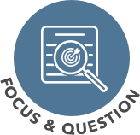
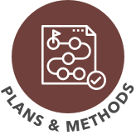
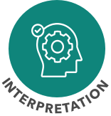
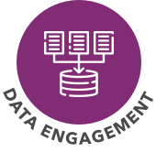
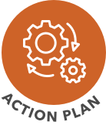
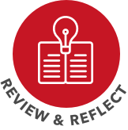

Reflective cycle of inquiry
Identifying points of interest
and possible goals (click here to edit this box)
Narrowing down focus and inquiry questions, linking to T-SEDA (click here to edit this box)
Planning the inquiry and
choosing methods and tools (click here to edit this box)
Considering the findings and reflecting
on what they might mean (click here to edit this box)
Conducting the inquiry
and gathering evidence (click here to edit this box)
Developing practice
based on the findings (click here to edit this box)
Considering how the whole
process has worked (click here to edit this box)

